Developments in Remote Magnetic Monitoring of carbon steel pipelines to locate and Measure Abnormal Stress.

Hamed Habibi,
MSc, MME, Technical Director, Speir Hunter
Mayden House, Main Street
Long Bennington, Newark
NG23 5DJ, UK

Abstract

Conventional pipeline integrity solutions quantify the defect geometry in a pipeline wall, relying, for example on the identification of a defect category (crack, or corrosion) and its size (wall thickness loss). However, the most important dimension for integrity decision-making concerns the underlying quantity of stress. Defect geometry is often used to infer the stress-value in a pipeline. Once this stress-value reaches the pipeline maximum material strength it causes plastic deformation and rupture of the pipe. Large Standoff Magnetometry (LSM) is an innovative form of Remote Magnetic Monitoring (RMM) technology that provides direct measurements of stress quantities in pipeline wall material through the analysis of pipeline magnetic data. This paper explains the basic principles of LSM through the example of a leading LSM technology, SCT (Stress Concentration Tomography). It will then present verification data summarising the effectiveness of SCT based on data collected in the field.

Keywords: RMM, LSM, SCT, SCZ, Localised Stress, Stress Monitoring, Condition Assessment, Pipeline Integrity.

1 Introduction

For many years, integrity solutions have been based on the geometry of defects, as almost all conventional methods of inspection are only able to measure the size of the defect. There were also different techniques developed for each defect category. What causes the problem for the integrity managers is, however, stress in pipeline wall that reaches its maximum material strength and then fails. Many experiments and studies have been carried out to take the size, type, and position of defects, operating condition of the pipeline and many other factors into account, when an integrity decision has to be made. These techniques have to be very conservative and therefore not very efficient, even if only one inspection method can cover all types of defects on a stretch of the pipeline. Remote Magnetic Monitoring (RMM) of carbon steel pipelines is an innovate approach to directly assess the integrity condition of pipelines, regardless of any other factors including type of defect and operating condition. This method of inspection is now known internationally as Large Standoff Magnetometry (LSM) and this article describes the principles in more detail, recent developments in the technique, and gives some examples of use of one of leading technologies named Stress Concentration Tomography (SCT).

2 Background

The science of stress-magnetisation of steel, known also as Inverse-Magnetostriction, was little known until recently. Magnetostriction was first established by Joule in 1842 using a bar of Iron and mechanical levers to show that a bar expands in the direction of applied magnetisation. [1] In 1865, Villari showed a tensile stress on a bar of steel will alter the magnetic field around the bar which is known as Inverse-Magnetostriction, or Villari Effect. [2] Over the past decades, Inverse-Magnetostriction has been studied within close range of steel bars. Staples et al. all discovered in precise detail the relationship of stress and magnetic fields produced by steel structures under localised corrosive, metallurgical and mechanical stresses, focusing on steel pipe sections. [3] Magnetic field was accurately measured in close and far range of steel bars, and a mathematical model was suggested for the relationship between a one-dimensional stress and changes in magnetic field. This was the first attempt to study Inverse-Magnetostriction for far ranges. The model was expanded for three-dimensional stresses and verified on a single suspended section of pipe that was end capped. Stress in the pipe wall was produced by an external load in the middle and pressurising the pipe section. Pushing the pipe in middle will trigger an immediate magnetic response from the pipe that even a conventional compass is able to reveal. Although the developed mathematical model has been verified successfully, the explanation of this phenomenon is still hypothetical. When a ferromagnetic pipe segment is being manufactured in the mill, it will effectively become a bar magnet with a north and south pole as it freezes beyond its curie point. Magnetic domains will be formed and depending on curing conditions, their magnetic poles will be arbitrarily oriented. This configuration will remain the same until two facts effect it. The first, which is more widely known, is an external magnetic induction that can rotate the magnetic dipoles. This is the most common way to make permanent magnets. The second fact, which was studied by Staples et al., is that a microscopic mechanical deformation will mechanically change the orientation of dipoles. For instance, a longitudinal tensile stress will mechanically stretch the magnetic domains in the same direction and force the orientation of dipoles to be more towards that direction. More aligned magnetic dipoles mean a stronger magnetic field, which can even be detected remotely.
For a pipeline in operation, operating conditions will introduce a uniform stress in longitudinal, circumferential and radial directions along its length. This will create a baseline for the magnetic field that can be measured at a distance from the pipe. Developed defects like corrosion, cracks, dents, etc. and external forces such as land movements, will cause and increase in local stresses compared to an undamaged section of the pipe. This will change the original orientation of magnetic dipoles locally, which in turn disturbs the base line magnetic field. This is a magnetic response to increased localised stress which is known as Magnetic Signature (MS) of a localised stress, or a Stress Concentration Zone (SCZ). Although magnetic signatures are of a minute intensity, they are detectable by the advanced technology instruments available today.

3 Characteristics of Remote Magnetic Monitoring

The technical and commercial advantages of RMM as an inspection tool for pipelines are many. It is a remote inspection technology that requires no contact with the target, nor the input of energy into it. It can detect a phenomenon that is occurring naturally and therefore detects every cause of increased localised stress from corrosion, cracks, lack of penetration in welds, Stress Corrosion Cracking (SCC) through to twisting and bending caused by earth movement. Because it is a remote inspection technique, there are no limitations due to the pipeline build configurations, no required change in operational conditions, and therefore no hidden costs.

Detecting Magnetic Signatures was one of the main challenges when developing RMM, but understanding them was even more challenging. In the absence of scientific papers acknowledging the existence of – and documenting the behaviour – of stress magnetisation, a means of detecting and storing magnetic signals generated by defects needed to be designed, and then the data collected had to be understood and interpreted. RMM have been successful in both challenges. To collect data a tool consisting of a scanner bar and a survey-grade positioning system was designed which is capable of stamping accurate geo-coordinates to recorded magnetic and other sensors data.

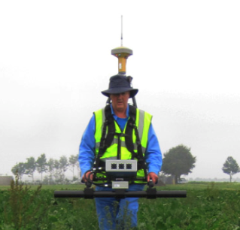
Figure 1. scanner remotely collecting pipeline and positional data

Knowing the mathematical relationship between magnetic signatures and their source, the existence and position of pipe wall defects to centimetre accuracy can be predicted. The magnitude of localised stress within the defect can be estimated to 25MPa accuracy regardless of its source, thus a localised stress profile of the pipeline wall can be produced. RMM can also detect and identify the location of beginning and end of casings, wall thickness changes, diameter changes and wrinkle bends, again all to centimetre accuracy. It can also detect the location of stuck In-Line Inspection (ILI) tools but perhaps its most unique capability is the 3-dimensional mapping of a pipeline route using magnetic data that includes depth of cover, terrain altitude and accurate pipeline route. Detection of Girth Welds (GW) is under development to achieve industrial standard specifications.

In the following sections, some field verifications of RMM results are presented. They are examples of a few of the types of defects among the many, that have been successfully detected by SCT. A more detailed field verification of RMM is provided by Habibi et al. [4]

3.1 Corrosion and Metal Loss

Metal Loss is the most common defect causing problems for pipelines, and corrosion is known to be the source of many of them (metal loss could also happen due to mechanical damage or construction issues). A reduction in pipeline wall thickness will increase the density of stress flow lines around the area and cause stress concentrations. For a pipe under operating pressure, circumfrencial stress is normally the most dominant stress and the stress concentration is more likely to increase in the same direction.

This example concerns a pipeline inspected in 2009 in which severe defects were discovered and consequently repaired. The inspection was repeated in 2015 with Magnetic Flux Leakage (MFL) method focusing on metal loss type of defects by an In-Line-Inspection (ILI) tool and two spots were identified for two individual costly repairs based on having lost around 20% of wall thickness.

An SCT scan was carried out following the repeated ILI run in 2015 on a 500m stretch of the line without knowing the location of these defects. One of the defects was a matched with the defect reported by SCT to have the highest stress level along the survey length, while the other one was estimated to have a much lower stress level despite having a similar pit depth to the first one. Figure 2 shows the staked out SCT indication that was only 15cm away from the actual defect and Figure 3 shows the actual defect exposed in 2015. The SCT report in 2015 showed that the worst defect had the stress level of 67% of the Specific Minimum Yield Strength (SMYS) of material while ILI reported a 26% wall thickness loss.

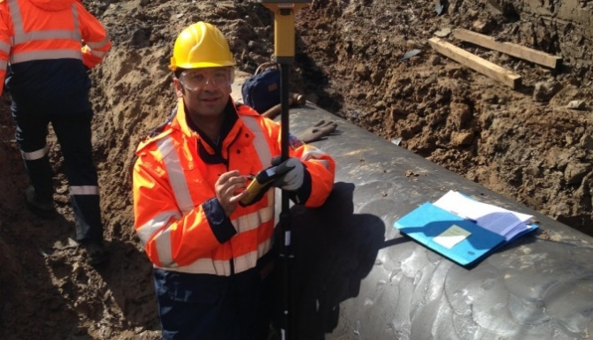
Figure 2, The survey pole shows the exact location of reported SCZ that was only 15cm away from the actual defect.
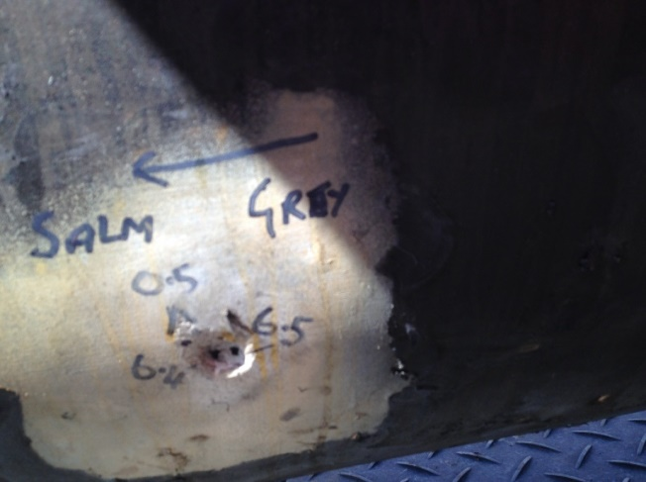
Figure 3, External corrosion metal loss with 26% wall thickness reduction

The second defect was reported by ILI to have possessed 19% wall thickness loss. The pipeline owner was obliged to repair any defect with ≥ 20% wall thickness loss. Due to the high risk factor of this particular indication, the pipeline owner decided to excavate and repair it. The decision was made based on defect geometry only; SCT’s stress estimation declared the overall stress-value of this point in the pipeline to be only 30% of the material SMYS – well within acceptable range.

After an expensive excavation to expose the second spot, it was found that the defect had been repaired in 2009 via. sandblasting and recoating. However, the repair records were lost sometime between 2009 and 2015, the year when the SCT inspection was conducted. Although the depth of metal loss was still at 19% of wall thickness, smoothing the surface reduced the localised stress. The geometry remained more or less the same prior to and after the repair, but the quantity of localised stress decreased. Whereas ILI’s measurements were based on defect geometry, SCT’s measurements were based on direct stress-value estimations. As shown by this example, stress monitoring approaches could have saved the budget of the second excavation by enhancng the conventional criteria which are based on defect geometery only.

In general, verifying the accuracy of SCT’s reported stress level is hard to achieve in real-world conditions. But after the exposure of defects, their dimensions were precisely recorded and a three-dimensional geometry model was developed based on that to clacluate the localised stress at the defects under the same operating condition at the time of inspection. All calculations were performed using Finite Element Analysis (FEM) and the derived results closely matched the stress-levels reported by SCT.

3.2 Cracks and Stress Corrosion Cracking

A further unique feature of SCT is its ability to detect cracks at even the micro-crack stage prior to serious damage being caused to the pipeline. In this example the cracks detected were shallow and the pipeline was repaired simply by grinding out the cracks before any serious damage had occurred. Two exposed defects were within 100m of one another. One at micro-crack stage with the maximum length of 10mm and the other had some longitudional long cracking of around 140mm. SCT reported SCZs at these two points to have around 68% of SMYS. These two defects can be seen in Figure 4 and Figure 5.

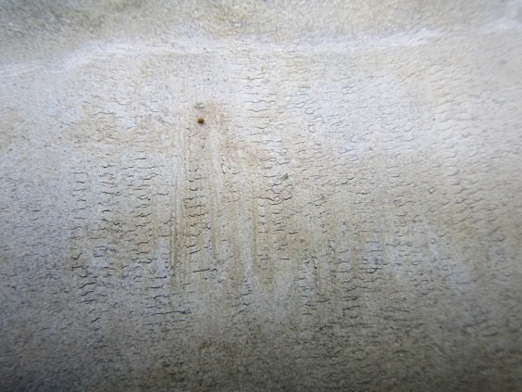
Figure 4, Micro-cracks, with the longest one being 10mm.
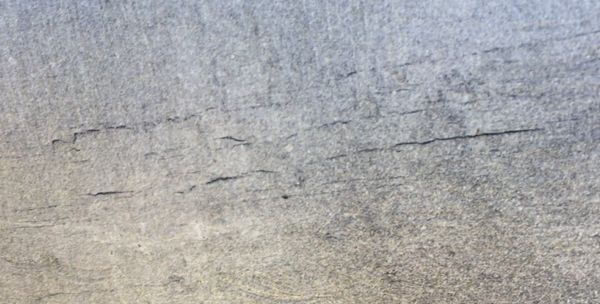
Figure 5, Longitudinal linear indications, with the longest one being 140mm.

3.3 External Loads

Another advantage of monitoring stress in pipe walls instead of geometry change is that any external load that exerts localised stress on the pipe could be detected. However, SCT cannot identify the source of stress concentration. Another capability of this technique becomes beneficial in this situation. For example, SCT’s reported data on the pipeline route and its depth of cover reported helped identify a serious deflection in a pipeline route caused by underground earth movement. The reported change in the pipeline’s depth of cover suggested that the pipe had suffered from a landslip. Upward buckling in the same area showed several SCZs with noticeably higher stress levels, suggesting structural damage caused to the pipe by underground earth movement. Figure 6 illustrates a top view of this lateral deflection.

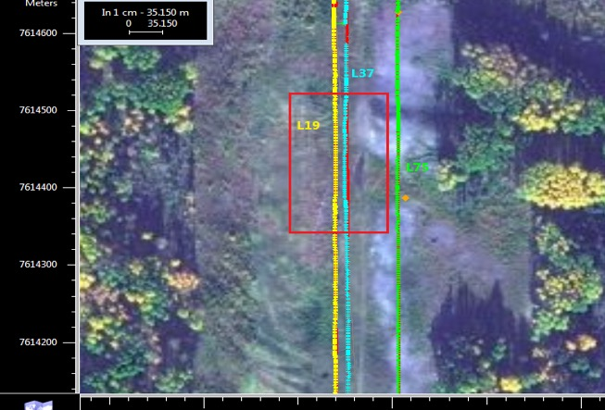
Figure 6, Blue pipeline route shows a lateral deflection from a straight line due to landslip.

3.4 Defects at Welds

SCT is also capable of not only identifying the location of girth welds but also of detecting if there are weld defects and/or corrosion close to, or on the weld. In this example, a missmatch at the weld caused a leakage of water under the coating resulting in an area of external corrosion pitting of 638mm by 180mm, with the maximum depth of 8% of wall thickness. The wall thickness change was along the girth weld and caused denting at the other side of pipe in order to force the alignment. Figure 7 shows the mismatch a 12 o’clock position while Figure 8 shows the dent at the 10 o’clock position. The mismatch and the dent led to water getting under the coating and caused pitting, as shown in Figure 9.

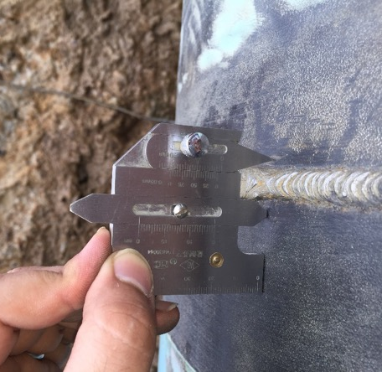
Figure 7. 2mm mismatch at a girth weld.
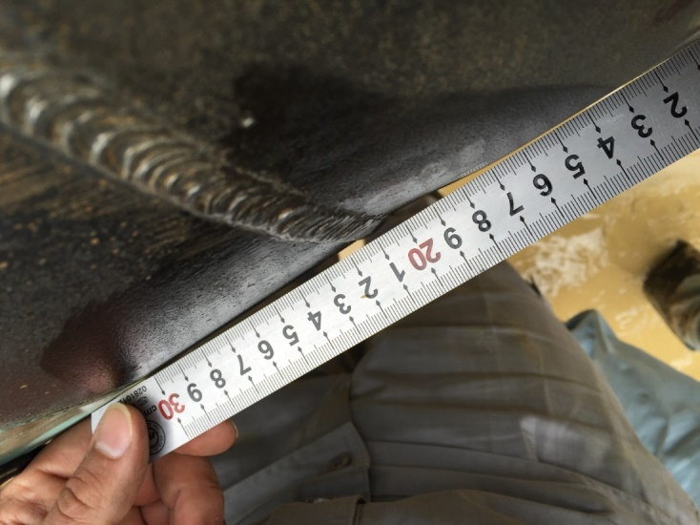
Figure 8, 4.25mm dent near weld between 9 – 11 o’clock position

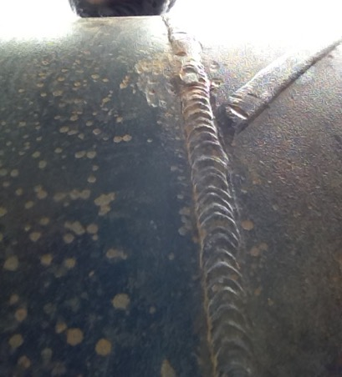
Figure 9, Pitting next to a girth weld because of presence of water under coating due to mismatch.

4 Implementation of Remote Monitoring Magnetometry

Adding RMM technologies to intergrity solutions portfolios has not been a straight forward task. For years, integrity solutions of pipelines have been based on defect types and dimensions and decisions have been made on established conventional approaches. Measuring stress level, desipite being the ultimate goal of inspections, sounds unfamiliar when it comes to taking actions. There are not internationally recognisable intergiry protocols that are based on stress. However, ignoring maximum allowable stress in a pipe wall for designing a pipeline is impossible. Many complanies conducted their trial of RMM to evaluate its performance or to find a solution for special situations that their pipelines intergirity have. This could be from having an unpiggable pipeline to a restricted maintenance budget.
Some companies started to benefit from RMM in their intergiry programme by using it as a complementary tool to their existing portfolio of technologies. For instance, they use this technique to prioritise their maintenance and repair or to make decisions where conditions of conventional protocols are not met marginally. RMM is capable of scanning short stretches of the pipelines in a short time that makes it practical to monitor intergrity condition of suspected areas. Developing geographical mapping of pipelines and resolving special situations are among other circumstances where companies started to use RMM.

4.1 Challenges Ahead of Full Implementation

There are some challenges ahead of integrity engineers to fully integrate RMM in their inspection bascket. One of the major challenges is to convince their managers about perfromance of RMM. Specifications of the technique are clear but interpretations cause most of issues. The main subject of debates is how to distinguish between a matched and missed alignment of RMM results versus conventional techniques. There are two approches on this matter. First one takes indications from coventional methods as reference point and matches RMM indications with them. This will cause many errors because RMM reports one SCZ which reflects the highest localised stress in an area with its geometric centre without considering number of defects and type of them. Using the first approach, RMM will miss all defects if there are more than one defect in an area of the pipe. The second approach takes RMM indications as refrence. Thus, all defects will considred as hit when they are within the range of positional acuuracy of the RMM technique. For instance, all five defects that are reported by ILI and are within 1m of SCT indication will be considered as a matched result.

The second major challenge is to correlate the visual severity of a defect with reported stress levels by RMM. This is very complicated and there are much more parameters involved in it than only dimension, clock position or type of defect. It is somehow achievable in controlled environemnt or by computer simulation. However, knowing the localised stress level is much more useful than knowing about geometery of the defect. On the other hand, there are some stress concentration areas that are not caused by a geomtery change in pipe wall like when an external force is exerted on pipeline.

4.2 Verifications Peformance

In this section, the overall performance of Stress Concentration Tomography in verification trials is statistically addressed. This technique is being used by many clients that have been trialled it at the first step. As explained in previous section, the SCT indications are considered as refrence points to hit rate againt conventional methods or observations after excavations. These figures can be extended in future scenarios to illustrate the Probability of Detection (PoD) of the technique once enough data is availabe. Currently the numbers are expressed as hit rate to give intergirty engineers a general idea of SCT performance.

A total of 25 SCT surveys are studied against ILI results. A hit is counted when there is a defect reported by ILI within a certain range from the reported SCZ. Claimed positional accuracy of an SCZ for SCT is ±1m. Table 1 lists the hit rates among aforementioned trials for claimed positional accuracy.
Table 1. Hit rate of SCT results against ILI among 25 verification trials.
Survey No. | Total No. of SCT indications | Total No. of ILI indications | Hit Rate within claimed positional accuracy | Hit Rate within double the range of claimed positional accuracy
1 | 69 | 16 | 81% | 81%
2 | 40 | 17 | 65% | 71%
3 | 77 | 6 | 100% | 100%
4 | 34 | 17 | 82% | 100%
5 | 77 | 6 | 100% | 100%
6 | 59 | 3 | 100% | 100%
7 | 50 | 3 | 67% | 100%
8 | 58 | 40 | 100% | 100%
9 | 61 | 1 | 100% | 100%
10 | 21 | 4 | 100% | 100%
11 | 43 | 1 | 100% | 100%
12 | 30 | 1 | 100% | 100%
13 | 21 | 1 | 100% | 100%
14 | 31 | 9 | 100% | 100%
15 | 30 | 1 | 100% | 100%
16 | 32 | 5 | 100% | 100%
17 | 50 | 1 | 100% | 100%
18 | 45 | 1 | 100% | 100%
19 | 91 | 132 | 84% | 93%
20 | 65 | 4 | 75% | 100%
21 | 46 | 10 | 90% | 90%
22 | 292 | 4 | 50% | 100%
23 | 231 | 4 | 25% | 75%
24 | 175 | 6 | 83% | 83%
25 | 75 | 2 | 100% | 100%

The number of SCZs are normally more than number of indicatiosn from ILI. This is due to the fact that many ILI indications are eliminated from the results because they are either within allowance or less than the PIG’s minimum resolution threshold. However, SCT reports any increase in stress concentration above the operational hoop-stress of the pipeline. When number of ILI indications are more than number of SCZs, the main reason is that there are some areas with many individual defects next to one another. Under these circumstances, ILI reports them individually while SCT reports one SCZ with the highest stress-level to represent an area characterised by a cluster of SCZs that are very close to each other positionally.

5 Conclusion

Monitoring stress has many advanages over conventional and traditional methods of inspecting defects. It can lead to a more accurate assessment of the defect in terms of severity. The existence and location of these defects can now be identified through an automated algorithmic analysis of magnetic data collected by using magnetometers. Some examples of the defects that have been successfully detected by this technique have been discussed. It has taken many years to reach this stage of development and in addition to SCZ detection, stress-estimation and pipeline 3D mapping, SCT is now being deployed commercially in the non-piggable market as a complementary tool to DCVG and as an additional tool in the external and internal corrosion direct assessement (ECDA and ICDA) process. Moreover, SCT has shown its value in the piggable market where it has demonstrated a considerable number of pipeline integrity applications: it is being used as a screening tool to guide the deployment of established high resolution tools; to guide excavation teams to accurate dig locations; to detect stuck inspection PIGs; to map pipeline routes and features such as casings and wall thickness changes; to assess potential threats to pipelines in geohazardous locations; and finally, to monitor depth of cover trends in areas of known soil erosion. The need for taking a conservative statistical approach to estimate the degree of danger of defects under operating conditions can be eliminated by using RMM, which directly assesses stress-levels. In the situations where no single conventional method can measure the geometry of a defect, such as when there is a combination of cracking and corrosion, the advantange of this technique becomes clear. There are still further steps left to produce an international recommended code of practice for the use of SCT results directly in intergity programmes. Until then, companies can set their own rules by trialling this technique, or by utilising SCT as a complemetary tool to prioritise their maintenace schedule, or increase the effectivenes of their maintenance budget.

References

[1] Joule, J. P., Sturgeons Annals of Electricity, 8, 359. (1842)
[2] Villari, E., Ann. Phys., Lpz., 126, 87. (1865)
[3] Staples, S. G. H. et al., “Solving the Inverse Problem of Magnetisation-Stress Resolution”, Journal of Applied Physics, 113, 133905 (2013)
[4] Habibi, H. et al., “Field Verification of Remote Magnetic Monitoring of Stress for Buried Unpiggable Pipelines”, Unpiggable Pipeline Solutions Forum, Houston, USA. (2017)

