Failures of insulating joints and spark gaps on the Hellenic Gas Pipeline System - a case study

Dr. N. Kioupis
Hellenic Gas Transmission System Operator (DESFA) S.A.
357-359 Messogion Ave., 15231 Chalandri, Greece
n.kioupis@desfa.gr

Th. Manolis, DESFA
P. Papadimitriou, University of Patras
C. A. Charalambous, University of Cyprus

Abstract
The practical experience derived from the field performance of IJs or flanges of the natural gas pipeline system of Greece is briefly presented. The defective insulation incidents on buried IJs were effectively mitigated by a proper surge protection scheme that has been applied. However, after a time period of a seemingly reliable operation, extending over a decade, two buried underground monolithic IJs lost their insulation properties despite being protected by properly installed ISGs. On another IJ the ISG malfunctioned whereas the IJ largely maintained its insulating properties. The causes of these failures are investigated and possible explanations are provided. The ageing and degradation of ISGs and the degradation of the dielectric strength of the joints is also discussed in the paper.

Abbreviations:
IJ = Insulating Joint
ISG = Isolating Spark Gap
CP = Cathodic Protection
3LPE = 3 Layer Poly Ethylene
HSS = Heat Shrinkable Sleeves
NGTS = National Gas Transmission System
EMI = Electro-Magnetic Interference

1.0 Introduction
The use of IJs on gas pipelines, serve the purpose of ensuring the electrical isolation among different sections of a pipeline routing. Their use is to prevent the detrimental galvanic cell interaction among different sections of pipelines and isolate stray current areas as well. Moreover, IJs are used to ensure the effective and homogeneous current dispersion on CP systems. To this extent, IJs failures can significantly impact the CP operation of a pipeline system. In turn, this may jeopardize the CP effectiveness and stray current control, maintenance and monitoring endeavours - thus increasing the risk for ac/dc corrosion, as a consequence. To avoid electrical failures, IJs are usually equipped with surge diverters to limit the voltage across the IJ. For example, monolithic IJs are rated at 5000 V and may be affected unless appropriate surge protection is installed. Particularly, within the clauses of the AUS standard [1] it is emphasized that surge protection against lightning may not be appropriate for the control of power line fault currents (50/60Hz)). Therefore, the IJs must be suitably rated (and protected) to also withstand the voltage imposed across them due to powerline faults.

With the above remarks in mind, the archived value of this paper derives from the field experience of the Hellenic Gas Transmission System Operator, and its continuous efforts to record and categorize the - IJs’ and surge-protection devices’ – failures on its system. It is worth noting that these efforts come in response to the world-wide scientific efforts that aim to understand the mechanisms of such field failures. It is highlighted at this point that this is a complex problem with multiple interacting variables, affecting the cause of these failures as well as the impact and consequences.
2.0. Background Information and Code of Practice
The field experience of the Hellenic Transmission system operator suggests that in the event of an IJ electrical failure, a thorough investigation should take place. This investigation entails decisions that would reflect either on immediate IJs’ replacement actions or on other peripheral measures to reinforce the effectiveness of the CP system (should the IJ replacement be deferred for practical or cost related matters).
It should be kept in mind that IJs replacement endeavours on a fully operational gas pipeline is usually implemented through the hot tapping/double stoppling method. This is a highly expensive process that entails safety risks, which the gas pipeline operator would be willing to avoid. Nonetheless, leaving an electrically failed IJ in service is a decision that must be very carefully considered. This is because by leaving a shorted IJ (or an IJ with reduced insulation properties) - some important questions are raised as to whether peripheral measures would be sufficient to maintain the CP effectiveness. For example, such peripheral measures may include the installation of drainage systems or the installation of additional rectifiers. These of course are subject to a sound reasoning, which evidently justifies that the CP effectiveness is not compromised by the IJ failure and therefore the IJ replacement can be deferred. To this end, the CP operator has the option to apply the norm for CP of complex structures which is described in EN 14505 [2], as an alternative to IJ replacement.
However, the need to replace the failed IJs cannot be averted at all occasions. For instance, the replacement can be become an immediate necessity when there is a gas leak through the insulation or when the reduction on their insulating properties is such, that renders CP ineffective. Some IJs are constructed in a manner that a gas leak through the insulation can be temporarily stopped or constrained by applying equipment such as emergency sealing gaskets or by other tightening measures. However, such measures for gas leak control are not and should not be considered as a permanent/effective repair method.
3.0 Evidence and Case Studies from the Hellenic Gas Transmission System
This section is organized as follows. Firstly, a brief description of the CP system associated with the main line of the gas transmission system is provided. Secondly, some documented incidents pertaining to IJs and ISGs failures in the Hellenic Gas Transmission are discussed. Thirdly, an IJ failure incident is analysed and discussed in more detail.
3.1 Cathodic Protection System of the Main Gas Transmission System [3-5]
The main gas line of NGTS of Greece extends from the Greek-Bulgarian borders to the west of Athens area. The pipeline had been installed between 1992 and 1995 (construction period). The burial depth range varies between 1 to 2 m. The factory coating is 3LPE with HSS at girth welds. The pipeline diameter is 30’’ with wall thickness ranging between 9,5 to 15,6mm. The CP system consists of 12 CP areas separated by monolithic IJs (Fig. 1). Each CP area is normally protected by means of one Rectifier. The numbering of CP areas increases from south to north. In this work, we focus on the IJs of the main line that are in sequential order (i.e. between areas 1-2, 2-3, 3-4, etc.) other than the IJs separating the main line from branch lines or earthed structures. The rectifiers are remotely monitored and their switching is controlled through a GSM wireless transmission system since 2006-2007. More details on CP and earthing system can be sought in the bibliography [3-5]. It is noted that the described incidents in the following sections of this paper, belong to this main gas line.
Figure 1 : Existing NGTS of Greece (the sites of IJ/ISGS in question are indicated by arrows)
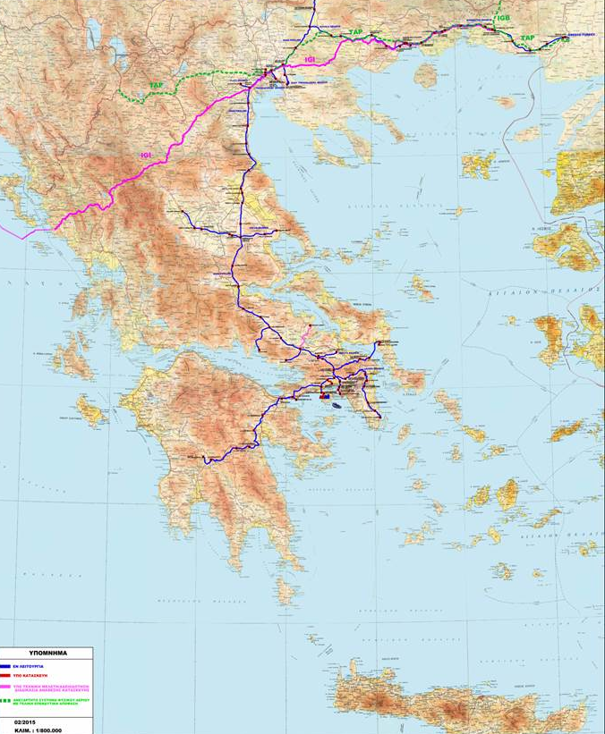
IJ 2-3
IJ 3-4
IJ 9-10

3.2 Brief Description of the Hellenic Experience
The few IJs’ failures encountered in the Greek gas transmission and distribution system, fall under the following three main categories:
- Electrical
- Mechanical
- Both mechanical and electrical
In the present work we will mainly describe some electrical failures of IJs and ISGs. The electrical failure of monolithic joints of the gas transmission and distribution pipelines of the Greek gas grid, (through the reduction of their insulating properties) was one of the most common types of incidents encountered. The failures were attributed to surge/lightning overvoltage effects or on short-term interference events, since such type of hazards had been underestimated at the design/construction phases of the pipeline. This underestimation had been partly reinforced by the fact that the technical standards (two decades ago), imposed ISG installations only in the hazardous (Ex) zones [7]. This interpretation had the consequence of leaving the IJs unprotected from electrically hazardous events. As a result some IJs in the NGTS have failed, i.e. they lost insulation effectiveness. The number of insulation failures detected during the first years of operation (1996-2002), was in the order of 7 failures out of 69. The latter figure (69) refers to IJs installed but not initially protected by ISGs. It should be noted, at this point that no insulation failures were detected on above ground IJs - installed between cathodically protected areas and earthed facilities - since these had initially been equipped with appropriate ISGs.
This failure figure (7/69) was considered a serious problem and an urgent project was launched to ensure that the remaining buried IJs would not fail. The remedial action involved the installation of ISGs on buried IJs of the gas transmission system, except on those IJs that had already failed. The ISGs were connected with 25 mm² cross section wiring with the shortest possible length to reduce their inductive impedance according to Afk no.5 [7] (see Figure 2).

Figure 2: Installation of the ISGs
The installation process started in mid-2002 and had been finalized in the first quarter of 2003. The typical technical data of the ISG initially installed underground, on the buried in soil IJs are presented in Table 1.

Table 1: Technical data of the ISGs initially installed
Nominal discharge current (8/20 μs) (I_{n}) | 100 kA
Lightning Impulse current (10/350 μs) I_{imp} | 50 kA
Rated impulse sparkover voltage (1,2/50 μs) U_{rimp} | ≤2,2 kV
AC sparkover voltage (50 Hz) | ≤1kV

Moreover, towards the end of 2007, two of the faulty IJs that were never protected by ISGs, had been replaced on the ‘live’ line by means of the hot tapping and double stoppling method. As part of the continuous efforts of the CP operator to record and categorize the failures on its system, these faulty joints were sent to their manufacturer for reconstruction (i.e. they were disassembled and reassembled). The disassembling of the IJs allowed the visual inspection of internal IJ parts and confirmed that the breakdown was caused by lightning. Some characteristic photos showing the cracks and carbonization traces on the insulating materials are illustrated in Annex 1 – [8].
However, in 2012 there were some measurement-based indications that the insulating properties of the - remaining in the system - faulty IJs, deteriorate with time. This has raised a question as to whether remedial actions should be immediately applied. The remedial options considered were two. The first option was to bridge the IJs above ground through the CP cabling, but this was immediately discarded because of the high inductive impedance of the bridging cable - produced by its relatively long routing and low cross sectional area of these cables [7]. The second option considered was to directly bridge the IJs at their physical installation locations (i.e. underground). The decision to enforce this action on all failed joints took place on February 2013. The bridging was enabled via three short cables of 25mm² pin brazed at symmetric positions around the IJ (see Figure 3).
Figure 3 : Bridging of the failed IJs
Through this interim action (i.e. the intentional underground bridging of the faulty IJs), the safety was reassured, since any lightning and fault currents would flow through the short circuit wires. A secondary benefit to the system’s operation was that the insulating materials of the IJs would not be overstressed by lightning/overvoltage effects and thus the possibility, of a further damage that would result in a gas leak - through the insulating material - would be minimised. Of course, following the IJ underground bridging option, the CP levels were readjusted accordingly to ensure the protection’s effectiveness.
3.3 Description and Analysis of a Specific Case-Study.
The following case study refers to an IJ that has electrically failed under field conditions, towards the end of 2012. This particular IJ is installed between CP areas 2 and 3 on the main line of NGTS (Figure 1). It is worth noting that in 2002, this particular IJ had been equipped with an ISG device.
For the pipeline sections that fall under CP area 2 and 3, the CP operator has been performing annual field measurements to document the effective resistance to earth values of those sections. These measurements reflect, in essence, the effective resistance to earth value that is produced: a) by the IJ and b) by the coated pipelines sections that are attached on either side of the IJ [6]. (Note: The coated pipelines sections could span away from the IJ for several km). Thus, a series of annual measurements corresponding to the pipeline sections between CP area 2 and 3 is shown in Graph -1.
Graph 1 : IJ’s Effective Resistance (to Earth Measurements) between CP areas 2-3 through the years

The results shown in Graph-1 can be interpreted as follows:
The effective resistance value of the pipeline sections that fall under CP area 2 and 3 had been gradually diminishing over the years. This diminishing was due to the IJ degradation or due to the pipeline’s coating degradation. In either case, the degradation suggests that the pipeline was subjected to electrically hazardous events (i.e. lightning activity, short-term EMI, etc.)
Moreover, in 2002 and prior to the installation of an ISG device to this IJ, some CP related measurements (i.e. switching on/off potential methodology) were carried out. These measurements are shown in Table 2:
Table 2 : On/off switching measurements 2002

CP area | Potential on (V) | Potential off (V)
2 | -2,85 | -1,42
3 | -0,86 | -0,85

During these measurements the rectifier at the CP area no.3 was disconnected and the rectifier at the CP area no.2 had been on/off switched. As can be seen in Table 2 there was a slight decrease on the area’s 3 potential (10 mV) synchronously following the switching of area 2. This was an indication that the IJ was not a perfect isolator [9]. Despite this indication, the IJ degradation was not considered severe and the operator proceeded with installing an ISG device, without any further investigation.
Nonetheless, approximately 10 years later, the CP monitoring data had shown some evidence of CP malfunction and disturbance. This was suggesting that the IJ or the ISG may be exhibiting reduced insulation properties; a possible IJ failure could be only confirmed by an excavation process. Thus, an excavation took place and it confirmed that the IJ had failed. In fact, the IJ was confirmed failed by several on site measurements (note: the ISG was temporarily disconnected during these site tests). On the contrary, the ISG was not detected shorted. The latter had been also confirmed by on-site measurements. Therefore, the buried ISG was disconnected and removed from service. It was immediately sent to the manufacturer for conducting forensic tests and for tracing any signs of accelerated ageing. The manufacturer’s tests and conclusions are briefly described below:
- Manufacturer’s Tests on ISGs
The ISGs removed from the failed IJ between CP areas 2-3 was subjected to the final clearance checks - as they are applied in the production process of similar ISGs. The final clearance check was carried out with a lightning impulse voltage of 1.2/50 μs wave shape at a peak value of 2.5 kV. To pass this test the ISG had to be activated at a voltage range between 1.2 kV and 2.5 kV. Any sparkover voltages below 1.2 kV or above 2.5 kV will result in failing the test. To this extent, Table 3 summarises two important conclusions that have been communicated by the manufacturer, upon the completion of the tests.
Table 3: Report provided by the ISG manufacturer

ISG at IJ 2-3: | Various sparkover voltages, mainly below 1.2 kV (test failed)
ISG at IJ 2-3: | The electrodes showed signs of erosive burning caused by temporary AC currents.

Nonetheless, the important conclusion was that the ISG electrodes had shown signs of erosive burning caused by temporary AC currents. This entails that AC interference (short or long term) may have a detrimental effect on IJ failures, should the protective measures (i.e. ISG) are unable to cater for the proper mitigation of short-term EMI.
- More IJ/ISG failures
In the meantime, two more incidents of IJ/ISG failures were found in the Hellenic System, which will be reported in a future work. The first incident refers to an IJ between CP areas 3-4. It is related to an ISG malfunction giving the impression to the operator of an intermittent IJs’ short circuit - depending on the AC interference levels at the time of IJ test the ISG was DC conductive or not. In this case, the ISG was replaced with another ISG having improved properties in terms of AC withstand capability.
The second case refers to IJ between CP areas 9-10 that is – similarly to the IJ 2-3 case - related to IJs’ electric failure while the ISG was not found in short circuit. The scenario that this IJ may also have suffered a dielectric degradation during the period that it was not protected by ISG (before 2002) cannot be excluded.
- Lab tests by CP operator
The CP operator proceeded with some preliminary testing in the lab on ISGs removed from service and compared them with a similar new ISG which had never been used in service. The methodology and test results are not yet publicly available. However, the preliminary results of this endeavour provide some evidence of a deviated performance of the used ISGs (in-service for 12 to 15 years) compared to the new ones (those not in service). However, a more systematic research and testing are required to understand the fundamental cause and mechanisms of ISGs’ degradation.

4.0 Further Discussion and Concluding Remarks
It is clear from the contents of this paper that the understanding of the mechanisms that lead to IJs failures is a complex process. This is due to the multiple interacting variables which affect the cause and time of these failures. The possible failure causes are summarised below:
- Inappropriate installation of ISG devices: This may entail the connecting ISG wires used have long wiring with insufficient cross sectional area creating high inductive impedance. The impact may be that the voltage developed on the IJ, in the event of a lightning strike, can be well above its dielectric strength due to the additional voltage being developed across the connecting wires.
- Natural Ageing and Moisture Ingress: The dielectric strength of the IJ may be significantly affected due to natural ageing factors or moisture ingress.
- Use of surge protective devices that are not appropriate for the control of power line AC fault currents: If the impact of AC interference is not taken into consideration, when designing the protection of pipelines from electrical hazards, then IJs may fail under severe AC fault conditions (if these are not properly mitigated by earthing arrangements or drainage systems).
It should be highlighted that the Hellenic Gas Transmission System Operator has dedicated significant time and efforts to record and categorize the IJs failures on its system. Most of these failures were electrical in nature. To this end, the operator is currently enriching his code of practice to this extent, by:
- Increasing the rate of periodical inspections of the IJ performance via remote monitoring of the CP system performance
- Implementing improved on-site measurement techniques and calculations for verification of isolating effectiveness of operating buried IJs [6]
- Gradual replacement of the inappropriate surge protection devices, with proper mitigation devices that are able to cater both for lightning and AC overvoltage events.
- Reinforce the R&D activities of the company to understand the fundamental cause of these failures, accounting for the impact of multiple interacting variables (e.g. weather, environmental material characteristics, presence and activity of nearby power lines). Where appropriate, more field tests will be carried out to link theory with practice.

Annex1 Photos of IJ disassembling and carbonization traces created by flashover sparks
During the disassembling only mechanical pressure was applied in order to separate the IJs parts. After disassembling the IJs, this was one view of the appurtenances. The burnings from the sparkover are visible (see arrows).
An other view of the IJs main body proves the existence of lightning sparkovers. The shape of the burnings proves indeed that the cause was surge/lightning currents.
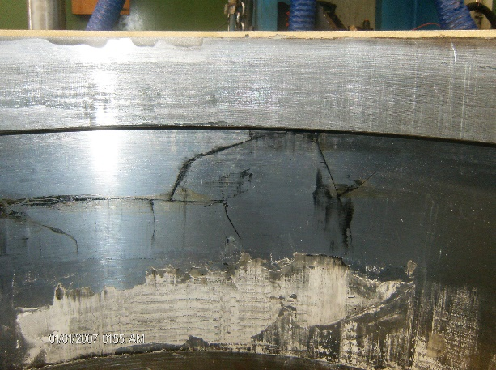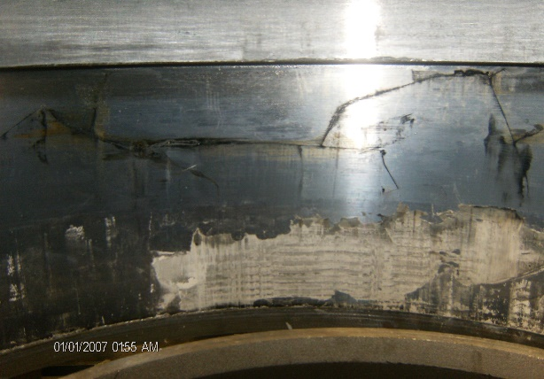

In the following picture we can witness the mechanical damage that was caused by the repetitive lightning strikes.

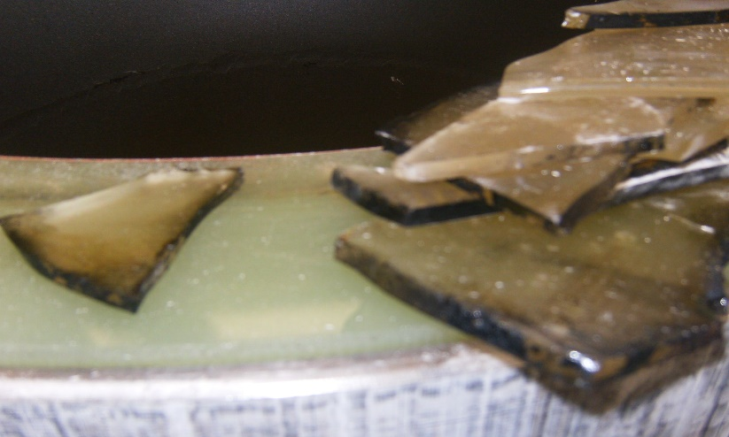
It is obvious that all insulating properties are lost and that the IJ has been susceptible to non-desirable effects; i.e. further mechanical damage with worst case senario the creation of arcs when lightning strikes occur.

Important note: Despite this damage the O-rings maintained the sealing properties.

Acknowledgements: To Professor El. Pyrgioti of University of Patras, Greece.

Bibliography
[1] AS/NZS 4853:2012, Electrical Hazards on metallic pipelines

[2] CEN EN 14505:2005. Cathodic Protection of Complex Structures, Brussels 2005.

[3] Kioupis N., Phd Thesis, National Technical University of Athens, May 2009.
[4] Kouloumbi N., Batis G., Kioupis N., Asteridis P., 2002. Study of the effect of AC-interference on the cathodic protection of a gas pipeline, Anti-Corrosion Methods and Materials (ACMM), 49 (5), 335-345.
[5] Kioupis, N., Kouloumbi, N., Batis, G., Asteridis, P., 2003. Study of the effect of AC-interference and AC-mitigation on the cathodic protection of a gas pipeline, In: CeoCor 6th International Conference, Giardini-Naxos Sicily 13-16 May 2003.
[6] Kioupis N., 2013 Cathodic protection testing of onshore gas pipeline IJs and similar piping accessories, In CeoCor International Conference, Florence 4-7 June 2013.
[7] DVGW 1986. AfK Recommendation No.5, Kathodischer Korrosionsschutz in Verbindung mit explosionsgefährdeten Bereichen, Feb. 1986, Eschborn.
[8] Th. Manolis, Report of disassembly of insulating joint on IJ manufacturer premises - May 2009 (not published internal report).
[9] B. Bazzoni, L. Lazzari, P. Fassina, V. Sia, Potential measurement interpretation on isolating joints Materials Performance, 39 (9), Sept. 2000, pp. 26-31.

